Protective eyewear for oral PUVA Photochemotherapy*

Psoralen tablets make both the skin and the eyes sensitive to light for some hours.
- Adults must wear protective eyewear during daylight and indoor light exposure until the end of the day (unless referrer has requested for longer) after taking tablets to avoid increasing the risk of cataracts (clouding of the lens of the eye).

- Children and high-risk patients (patients with pre-existing cataracts, atopic eczema etc.) must wear protective eyewear during daylight and indoor light exposure for 24 hours after treatment.

In children, eye protection is especially important because the immature lens in a young child can allow some ultraviolet A to reach the retina, raising a theoretical concern about potential for retinal, not just lens, toxicity if PUVA is given to a young child who might not fully comply with eye protection advice.

Protective eyewear can either be supplied by the phototherapy service or can be the patient’s own glasses / sunglasses. Protective eyewear should have lenses large enough and sit close enough to the face to prevent light entering the eye from around the frame. Patient eyewear must be checked to ensure it complies with the British Association of Dermatologists recommended transmission limits:

Transmission
<10% at 390 nm
<5% at 380 nm
<2% at 370 nm
<1% at 360 nm

Some prescription lenses may already include UV protection which meets the above criteria. The prescription glasses should be checked by the phototherapy service and if they do not meet the above criteria the patient may wish to either:

1. Have their prescription glasses UV protected
or
2. Be provided with protective eyewear that fits over their existing eyewear.

If the patient wishes to have their prescription glasses UV protected, they should speak to their optometrist and request lenses with greater than 90% UV protection. This is likely to incur a charge and therefore will not be an appropriate option for all patients.

All major lens suppliers can provide the required protection. This protection needs to be for light travelling through the lens as some lenses offering UV protection only offer protection from UV reflected from the back surface. It is therefore important that prescription glasses which have been UV protected must be re-checked by the phototherapy department. It is currently not recommended to rely upon contact lenses for UV protection.

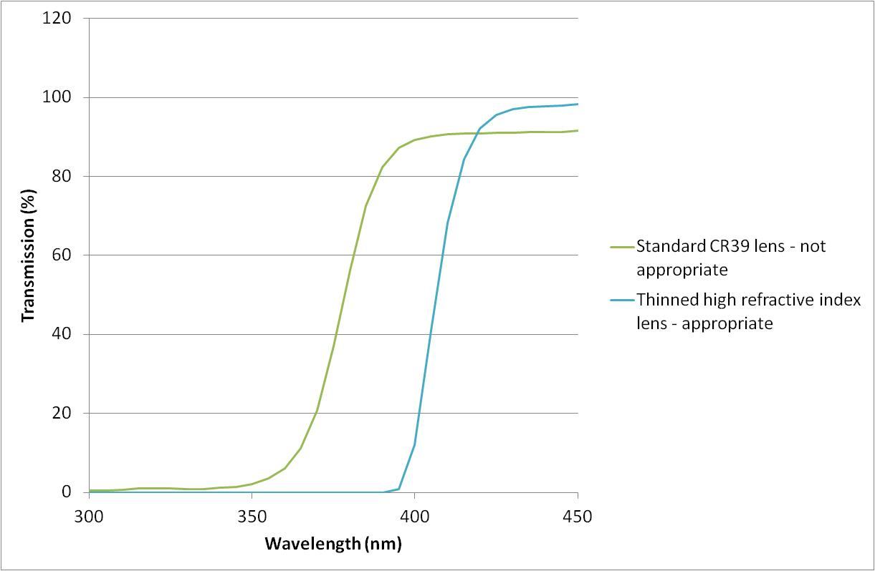
Figure 1 Example of lens transmission that does not provide enough protection for PUVA patients (Standard CR39 lens) and a lens that would provide enough protection (thinned high refractive index lens).

Acknowledgements
With thanks to David McIntosh, Independent Prescribing Optometrist, for his assistance in producing this guidance.

References
- Guidance for Dermatology Ultraviolet Phototherapy and Photochemotherapy for Children. Version 2. Review Date July 2020. https://www.photonet.scot.nhs.uk/professionals-area/standards-and-protocols/ [last accessed 16/08/2019].
- Photonet National Managed Clinical Network Treatment Protocols. Review Date October 2020. https://www.photonet.scot.nhs.uk/professionals-area/standards-and-protocols/ [last accessed 16/08/2019]
- Patient Information Leaflet: Phototherapy. British Association of Dermatologists. http://www.bad.org.uk/for-the-public/patient-information-leaflets [last accessed 16/08/2019]
- Ling, T. , Clayton, T. , Crawley, J. , Exton, L. , Goulden, V. , Ibbotson, S. , McKenna, K. , Mohd Mustapa, M. , Rhodes, L. , Sarkany, R. and Dawe, R. (2016), British Association of Dermatologists and British Photodermatology Group guidelines for the safe and effective use of psoralen–ultraviolet A therapy 2015. British Journal of Dermatology, 174: 24-55. doi:10.1111/bjd.14317
- (1994), British Photodermatology Group guidelines for PUVA. British Journal of Dermatology, 130: 246-255. doi:10.1111/j.1365-2133.1994.tb02910.x
- Moseley H, Cox NH, Mackie RM. (1988) The suitability of sunglasses used by patients following ingestion of psoralen. British Journal of Dermatology, 118:247‐253.

*This guideline is not intended to be construed or to serve as a standard of care. Standards of care are determined based on all clinical data available for an individual case and are subject to change as scientific knowledge and technology advance and patterns of care evolve. Adherence to guideline recommendations will not ensure a successful outcome in every case, nor should they be construed as including all proper methods of care or excluding other acceptable methods of care aimed at the same results. The ultimate judgement must be made by the appropriate healthcare professional(s) responsible for clinical decisions regarding a particular clinical procedure or treatment plan. This judgement should only be arrived at following discussion of the options with the patient, covering the diagnostic and treatment choices available. It is advised, however, that significant departures from the national guideline or any local guidelines derived from it should be fully documented in the patient’s case notes at the time the relevant decision is taken.

